Name: basil khowaja and aamaina mukaram id: bk08432 and 0

Lab 2 pre lab

TASK 1:

Voltage at the load:

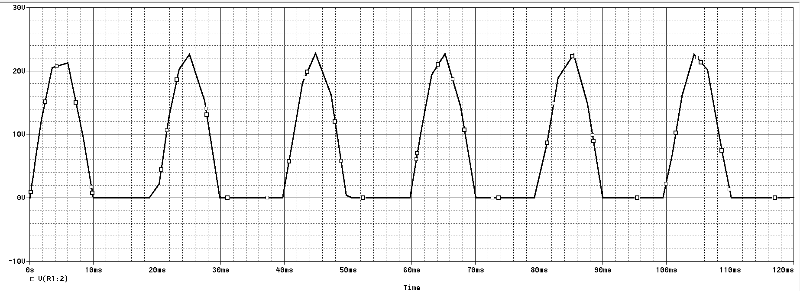

Seconary voltage of transformer:

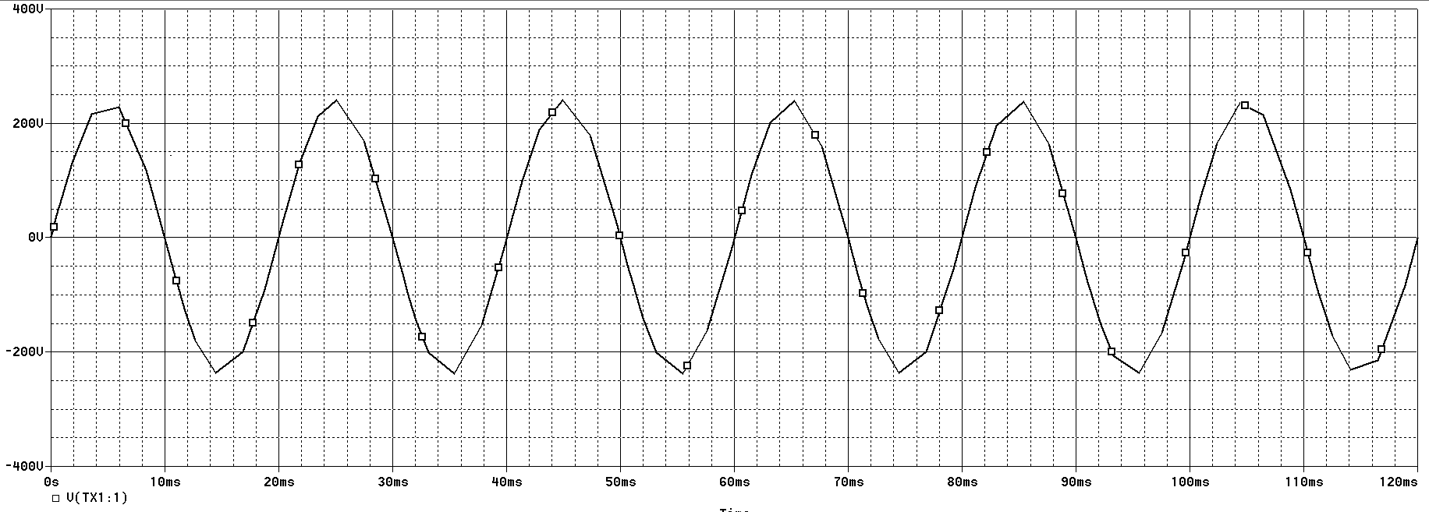

Voltage across the diode:

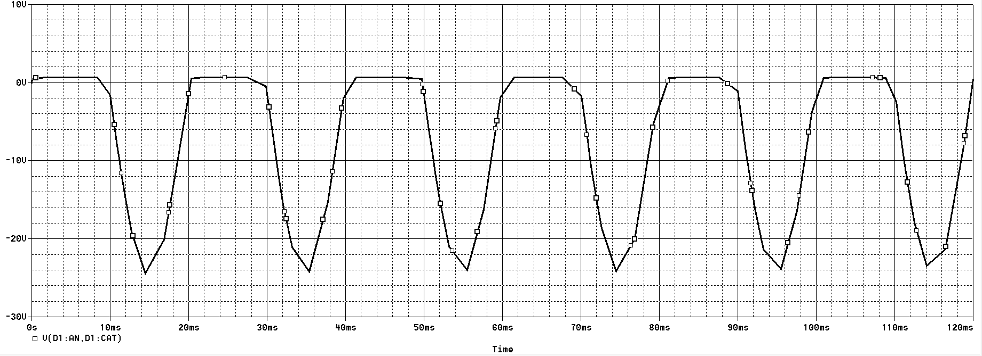

RMS value:

